Programming Fundamentals using Python - Part 1

# **Why Programming ?**

In today's digital world everyone uses computer and mobile phone. It is essential to know how to use the apps/programs on such digital devices and also the logic behind it works. Thus, knowing how to program will helps you understand and tinker with the world.

In this digital era, the knowledge of programming is essential to bring innovation and change. To create value with your own ideas you need know coding. **Programming has become basic literacy for the 21st century.**

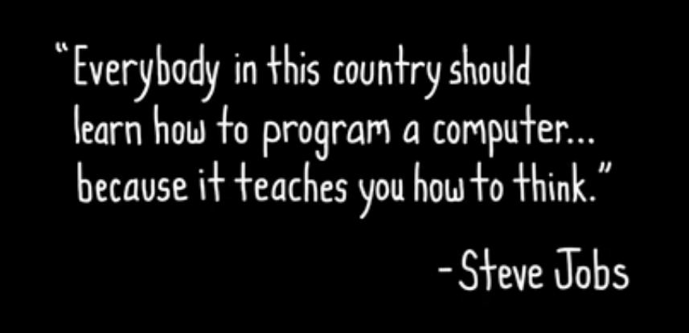

Various scenarios are used in an airport to discuss the concepts related to programming. Let us take a look at few of the processes that happen during takeoff and landing.

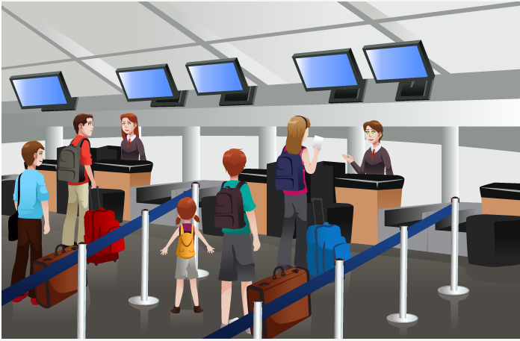

# **What is a program ?**

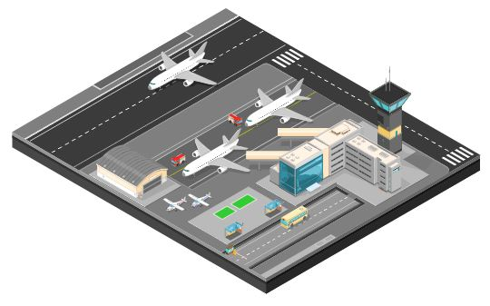

In the airport there are many flights landing and taking off. Unlike road traffic, the flights don’t have direct information of other flights around them. The Air Traffic Control (ATC) at the ground gives instructions to each flight on what it should do.

Similarly, instructions are provided to computer to accomplish specific tasks. Such instructions are known as program and the act of creating a program is known as programming.

Did you know? WhatsApp, Facebook, YouTube, Gmail are all programs!

# **Problem Solving**